**Project Report Template**

**CRM Application That Helps To Book A Visa slot**

**Introduction**

**A visa slot management project is a system that is used to track and manage the availability of visa slots, which are appointments that are required for certain visa applications. It might be used by a government agency or a visa processing center to schedule and manage appointments with applicants.**

**Problem Definition and Design Thinking**

**Empathy Map**

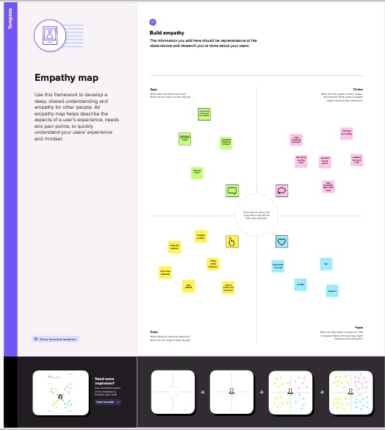 [**https://app.mural.co/invitation/mural/ppssteam9015/1679024343897?sender=u03f14a174af82897f13f8298&key=6b7a1ca3-5562-490c-a488-c012cf68c43c**](https://app.mural.co/invitation/mural/ppssteam9015/1679024343897?sender=u03f14a174af82897f13f8298&key=6b7a1ca3-5562-490c-a488-c012cf68c43c)

**Brain Storming Map**

[**https://app.mural.co/invitation/mural/ppssteam9015/1679124459138?9ca45cac0a6361796021&key=b1ef2d7c-98fa-4d4c-9add-204af892b08d**](https://app.mural.co/invitation/mural/ppssteam9015/1679124459138?9ca45cac0a6361796021&key=b1ef2d7c-98fa-4d4c-9add-204af892b08d)

**Result**

**Data model**

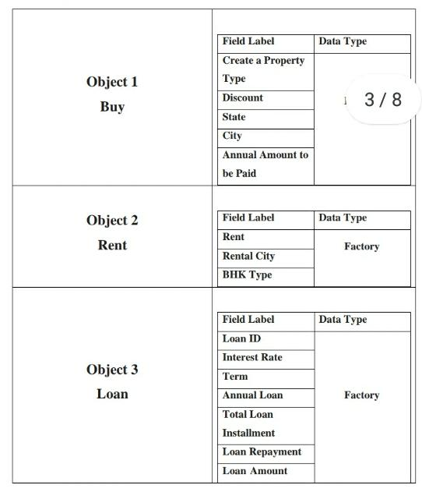**Activity and screen shot**

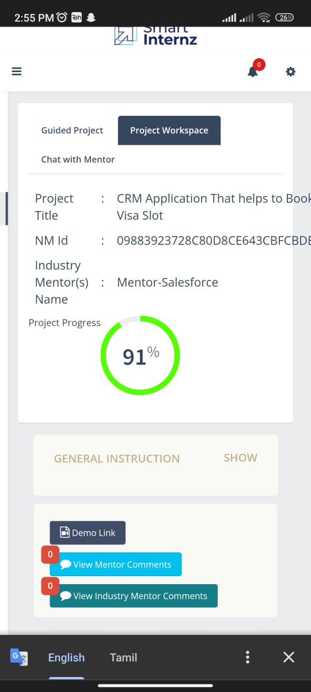

**Trailhead profile public URL**

**Team leader:** [**https://trailblazer.me/I’d/gmaheshwarI**](https://trailblazer.me/I’d/gmaheshwarI)

**Team member 1:** [**https://trailblazer.me/id/lalia6**](https://trailblazer.me/id/lalia6)

**Team member 2:** [**https://trailblazer.me/id/kkowsalya8**](https://trailblazer.me/id/kkowsalya8)

**Team member 3:** [**https://trailblazer.me/id/meenk15**](https://trailblazer.me/id/meenk15)

**Project Report Template**

**Advantages and Disadvantages of Online Booking System.**

**Advantages of Online Booking System**

**Your Business will be available 24/7.**

**• Reservation can be minimized anytime.**

**• Easier to manage the calendar.**

**• Conveniently manage everything through a single screen.**

**• Get Valuable insight about your business.**

**• An online Booking system saves a lot of time.**

**• Online Booking System is a modern approach.**

**• This helps in increasing sell-through upselling. ONLINE**

**• You will learn more about your customers.**

**• You get paid before providing services.**

**• Cuts the overloads of the staff's members.**

**Disadvantages of Online Booking System.**

**• Need a good internet connection.**

**High competition on the market.**

**Not every online booking system is equal, so you have to choose the best one as per your business.**

**Application Information**

**Please record your Application ID in a safe and secure place. If there are technical issues with the system, or you want to complete your application some other time, you can save your work and later, start where you left off. In order to access your application later, however, you will need: (1) your Application ID, and (2) the answer to the security question that you will choose on this page.**

**your application, or to use your previously provided application information to complete a new application at a later date.**

**If you do not plan to complete your application within the next 30 days, download your application to your computer by clicking the "Save" button at the bottom of the last completed page. Follow the instructions. When you are ready to complete your application, select "Upload an Application". NOTE: Only download your application to a computer that cannot be accessed by anyone who does not have your permission to see or record your personal data. If you download your application a shared or public computer, such as a computer in a cyber café or library, your personal information may be able to be accessed by other users.**

**Conclusion**

**1. The CMR application has been a great success in helping users book a resource slot in Salesforce. It has saved users time and effort, and made the process of booking a resource slot simpler and easier.**

**2. The CMR application has also improved the accuracy of resource allocation, as users are now able to book a resource slot in Salesforce with greater precision.**

**3. The CMR application has been a great asset for businesses as it enables them to better manage their resources and optimize their operations.**

**4. The CMR application has proven to be a great tool for both businesses and users alike, as it has enabled them to easily book a resource slot in Salesforce.**

**5. Overall, the CMR application has been an invaluable resource in helping users book a resource slot in Salesforce, and its success is a testament to the power of modern ttechnology**

**PROJECT DESCRIPTION**

**A visa slot management project is a system that is used to track and manage the availability of visa slots, which are appointments that are required for certain visa applications. It might be used by a government agency or a visa processing center to schedule and manage appointments with applicants.**

**Future scope**

**Firstly, candidates must fill out the I-20 application form, submit the SEVIS fee of $350 (29,000 INR), and then book an appointment at the Embassy**

**Business development, programming, and counselling** require these skills. These jobs are also amongst the best careers for the next ten years. Technological- This includes everything from basic to advanced IT skills, data analysis, and engineering. These future skills are likely to be the most highly paid.